Stock Transfer data model and template deployment.

Source: eigw-test.fa.us6.oraclecloud.com

Target: eigw.fa.us6.oraclecloud.com

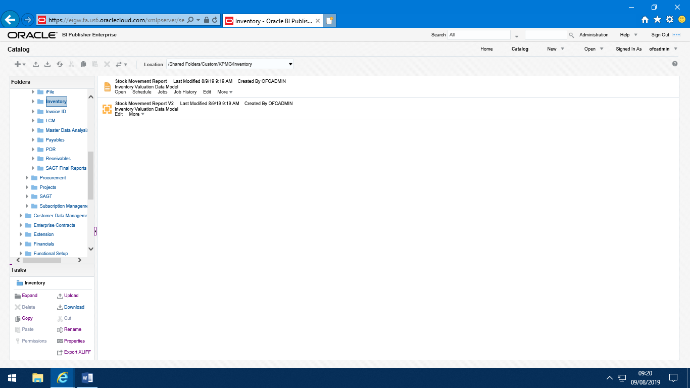

Daily Cost of Kitchen Issues Report deployment.

Source: eigw-test.fa.us6.oraclecloud.com

Target: eigw.fa.us6.oraclecloud.com

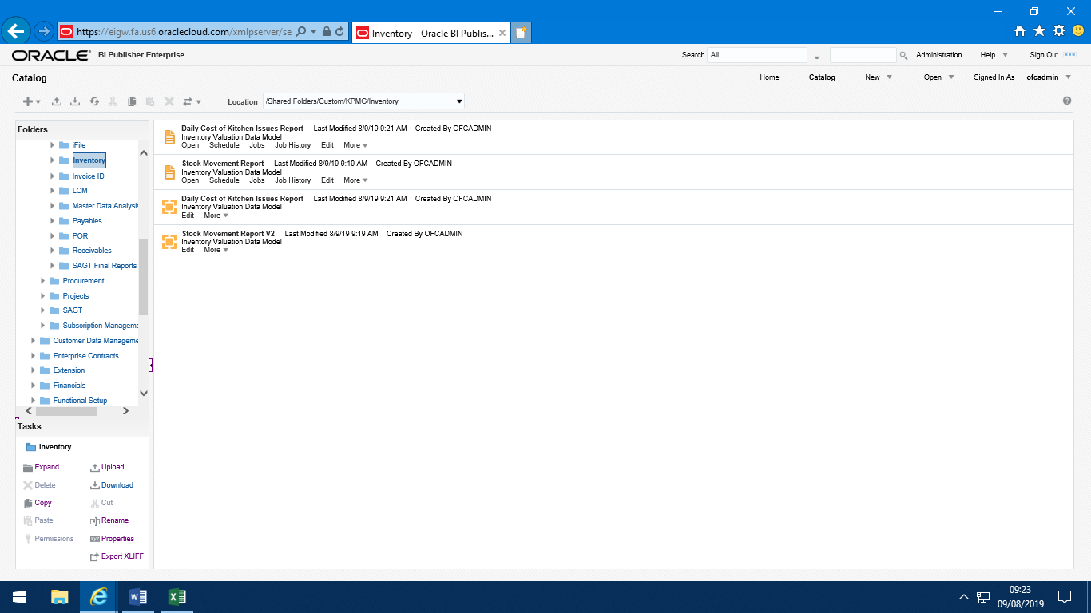

09/08/2019

Inventory Valuation Report data model and template deployment.

Source: eigw-test.fa.us6.oraclecloud.com

Target: eigw.fa.us6.oraclecloud.com

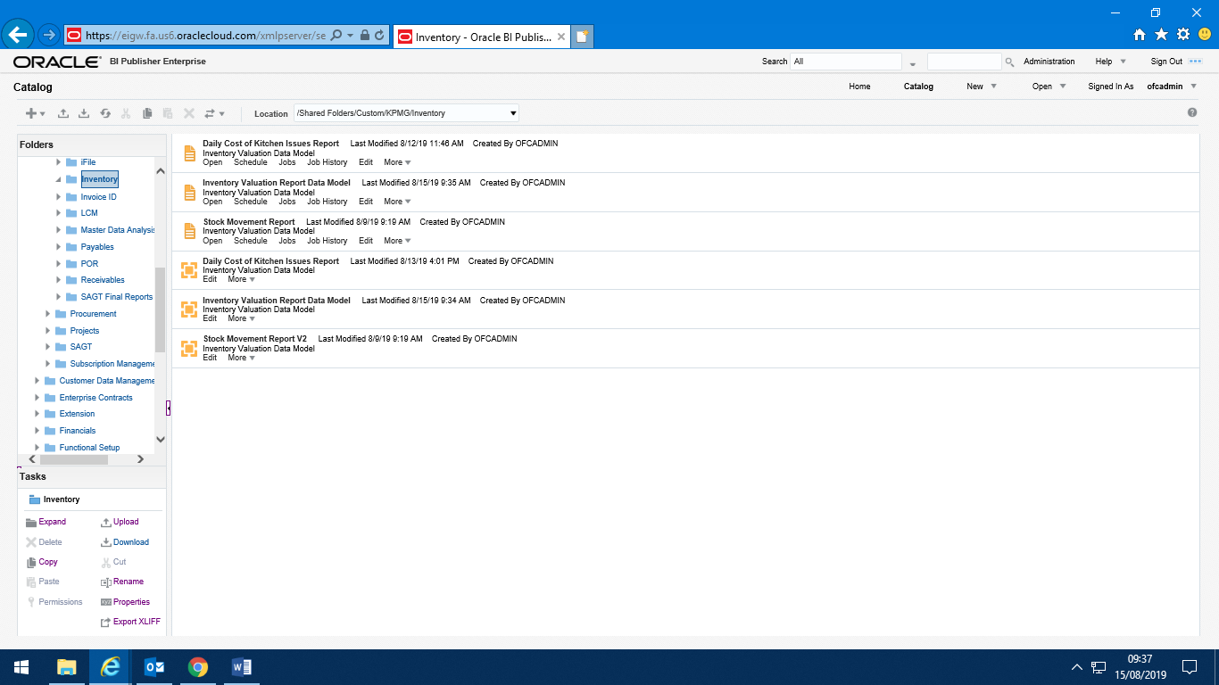

09:38 15/08/2019